INTRODUCTION
Architecturally, JSP may be viewed as a high-level abstraction of Java servlets. JSP pages are loaded in the server and are operated from a structured special installed Java server packet called a Java EE Web Application, often packaged as a .war or .ear file archive.
JSP allows Java code and certain pre-defined actions to be interleaved with static web markup content, with the resulting page being compiled and executed on the server to deliver an HTML or XML document. The compiled pages and any dependent Java libraries use Java bytecode rather than a native software format, and must therefore be executed within a Java virtual machine (JVM) that integrates with the host operating system to provide an abstract platform-neutral environment.
JSP syntax is a fluid mix of two basic content forms: scriptlet elements and markup. Markup is typically standard HTML or XML, while scriptlet elements are delimited blocks of Java code which may be intermixed with the markup. When the page is requested the Java code is executed and its output is added, in situ, with the surrounding markup to create the final page. JSP pages must be compiled to Java bytecode classes before they can be executed, but such compilation is needed only when a change to the source JSP file has occurred.
Java code is not required to be complete (self contained) within its scriptlet element block, but can straddle markup content providing the page as a whole is syntactically correct (for example, any Java if/for/while blocks opened in one scriptlet element must be correctly closed in a later element for the page to successfully compile). This system of split inline coding sections is called step over scripting because it can wrap around the static markup by stepping over it. Markup which falls inside a split block of code is subject to that code, so markup inside an if block will only appear in the output when the if condition evaluates to true; likewise markup inside a loop construct may appear multiple times in the output depending upon how many times the loop body runs.
The JSP syntax adds additional XML-like tags, called JSP actions, to invoke built-in functionality. Additionally, the technology allows for the creation of JSP tag libraries that act as extensions to the standard HTML or XML tags. JVM operated tag libraries provide a platform independent way of extending the capabilities of a web server. Note that not all commercial Java servers are Java EE specification compliant.
MySQL is a relational database management system (RDBMS)^{[2]} that runs as a server providing multi-user access to a number of databases. The SQL phrase stands for Structured Query Language.

The software components used in our project are as under:
- Eclipse
- MySQL database
OVERVIEW OF THE PROJECT

The Virtual Classroom is a collaborative teaching tool to assist the students to learn in an interactive manner. It aims to complement the efforts of teachers to integrate technology into their classrooms and link the students to the Internet in educationally productive ways and provide them a stimulating, positive and enjoyable environment to study.

It contains the following elements:-

1. Student Login:
It enables a person to login as a student or sign up if he/she has not registered for the classroom.
Once logged in a student has the following features:-
a) Edit Profile:
It allows modifying the details
b) Study Material & Video Lectures:
It displays a list of ppts & interactive video lessons categorized by subjects as posted by the faculty
c) Ask doubts:
It enables the students to ask questions
d) Answers:
It shows the answers by the teachers to the questions asked by various students
2. Faculty Login:
It enables a person to login as a faculty member or sign up if he/she has not registered for the classroom.
Once logged in a faculty member has the following features:-
a) Edit Profile:
It allows modifying the details
b) Study Material & Video Lectures:
It allows the faculty members to post & remove ppts & video lessons c) Doubts:
It shows all the questions asked by the students
d) Answers:
It enables teachers to answer the questions asked by the students
3. Administrator Login
The administrator is the ultimate controller of the application with the highest authority.
He/she has the following features:-
- Student/Faculty:
It displays a list of students/faculty members registered for the classroom
- Student/Faculty req:
It displays a list of students/faculty members whose sign up request is still pending
- PPT (pload/del)/Video(upload/del):
It displays a list of ppts & videos posted by the faculty members. The administrator has the power to remove ppts/videos from the list and upload according to wish
- Question/Ans
It displays a list of questions asked by students/answers to questions by teachers. The administrator has the power to delete questions/answers from the list.

ER DIAGRAM

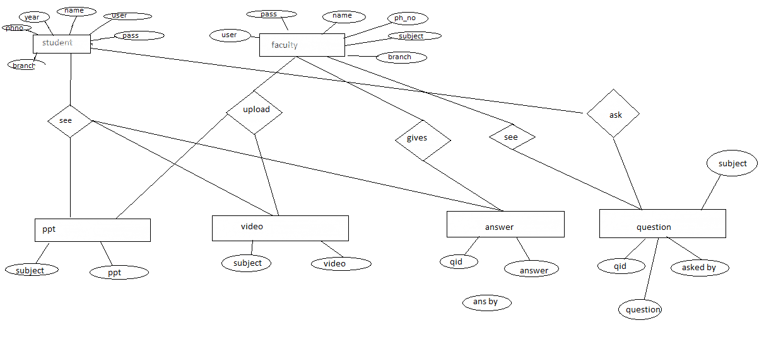

TABLE STRUCTURES
The structure of all tables included in the project is as under:-
- STUDENT

+--------+-------------+------+-----+---------+-------+
| Field | Type | Null | Key | Default | Extra |
+--------+-------------+------+-----+---------+-------+
| user | varchar(25) | YES | UNI | NULL | |
| pass | varchar(25) | YES | | NULL | |
| name | varchar(25) | YES | | NULL | |
| ph_no | varchar(25) | YES | | NULL | |
| year | varchar(2) | YES | | NULL | |
| branch | varchar(4) | YES | | NULL | |
+--------+-------------+------+-----+---------+-------+
- FACULTY
+---------+-------------+------+-----+---------+-------+
| Field | Type | Null | Key | Default | Extra |
+---------+-------------+------+-----+---------+-------+
| user | varchar(25) | YES | | NULL | |
| pass | varchar(25) | YES | | NULL | |
| name | varchar(25) | YES | | NULL | |
| ph_no | varchar(10) | YES | | NULL | |
| subject | varchar(25) | YES | | NULL | |
| branch | varchar(4) | YES | | NULL | |
+---------+-------------+------+-----+---------+-------+

- STUDENTSIGNUP
+--------+-------------+------+-----+---------+-------+
| Field | Type | Null | Key | Default | Extra |
+--------+-------------+------+-----+---------+-------+
| user | varchar(25) | YES | UNI | NULL | |
| pass | varchar(25) | YES | | NULL | |
| name | varchar(25) | YES | | NULL | |
| ph_no | varchar(25) | YES | | NULL | |
| year | varchar(2) | YES | | NULL | |
| branch | varchar(4) | YES | | NULL | |
+--------+-------------+------+-----+---------+-------+
- FACULTYSIGNUP
+---------+-------------+------+-----+---------+-------+
| Field | Type | Null | Key | Default | Extra |
+---------+-------------+------+-----+---------+-------+
| user | varchar(25) | YES | | NULL | |
| pass | varchar(25) | YES | | NULL | |
| name | varchar(25) | YES | | NULL | |
| ph_no | varchar(10) | YES | | NULL | |
| subject | varchar(25) | YES | | NULL | |
| branch | varchar(4) | YES | | NULL | |
+---------+-------------+------+-----+---------+-------+
- ADMIN
+-------+------------+------+-----+---------+-------+
| Field | Type | Null | Key | Default | Extra |
+-------+------------+------+-----+---------+-------+
| pass | varchar(5) | YES | | NULL | |
+-------+------------+------+-----+---------+-------+
- PPT
+---------+-------------+------+-----+---------+-------+
| Field | Type | Null | Key | Default | Extra |
+---------+-------------+------+-----+---------+-------+
| subject | varchar(10) | YES | | NULL | |
| ppt | varchar(50) | YES | | NULL | |
+---------+-------------+------+-----+---------+-------+

- VIDEO
+---------+-------------+------+-----+---------+-------+
| Field | Type | Null | Key | Default | Extra |
+---------+-------------+------+-----+---------+-------+
| subject | varchar(10) | YES | | NULL | |
| video | varchar(70) | YES | | NULL | |
+---------+-------------+------+-----+---------+-------+
- QUESTION
+---------+--------------+------+-----+---------+-------+
| Field | Type | Null | Key | Default | Extra |
+---------+--------------+------+-----+---------+-------+
| que | varchar(200) | YES | | NULL | |
| askedby | varchar(25) | YES | | NULL | |
| subject | varchar(10) | YES | | NULL | |
| qid | int(11) | YES | UNI | NULL | |
+---------+--------------+------+-----+---------+-------+
- ANSWER
+----------+--------------+------+-----+---------+-------+
| Field | Type | Null | Key | Default | Extra |
+----------+--------------+------+-----+---------+-------+
| qid | int(11) | YES | UNI | NULL | |
| answer | varchar(200) | YES | | NULL | |
| answerby | varchar(25) | YES | | NULL | |
+----------+--------------+------+-----+---------+-------+

CODE
<%@ page language="java" contentType="text/html; charset=ISO-8859-1"
pageEncoding="ISO-8859-1" import="java.sql.*"%>
<!DOCTYPE html PUBLIC "-//W3C//DTD HTML 4.01 Transitional//EN" "http://www.w3.org/TR/html4/loose.dtd">
<html>
<head>
<meta http-equiv="Content-Type" content="text/html; charset=ISO-8859-1">
<title>profile</title>
</head>
<SCRIPT type="text/javascript">
window.history.forward();
function noBack() { window.history.forward(); }
</SCRIPT>
<body background="G:\Classroom1.jpg" bgcolor="red" >

<form action="main.jsp" method="post" >

<table width="960" border="0" cellpadding="0" cellspacing="4" bgcolor="grey">
<tr>
<td>
<center><img src="D:\New folder\Web Page Header.gif" width="960"height="100" ></center>
</td>
</tr>
<tr>
<td align="left" style="word-spacing:6px;font-size:120%;padding-right:30px;color:#888888;white-space:nowrap;">
<a href="studlogin.jsp" title="student">Student login </a> |
<a href="faclogin.jsp" title="faculty"> Faculty login </a> |

</td></tr>
</table>

<table>
<tr><td>
<tr><td>Admin Login
<tr><td><input type="password" value="" name="pass" >
<tr><td><input type="submit" value="Login" onclick="fu(this.form)" >
</td></tr>
</table>
<%

String pass1=request.getParameter("pass");
try{
Class.forName("sun.jdbc.odbc.JdbcOdbcDriver");
Connection c= DriverManager.getConnection("jdbc:odbc:akb", "root", "root");
Statement s= c.createStatement();
String sql="select pass from admin";
ResultSet rs= s.executeQuery(sql);
rs.next();
if( pass1.equalsIgnoreCase(rs.getString(1)) )
{
%>
<jsp:forward page="admin.jsp"></jsp:forward>
<%
}
rs.close();
s.close();
c.close();
}
catch(Exception e) {}
%>
</form>
</body>
</html>

<%@ page language="java" contentType="text/html; charset=ISO-8859-1"
pageEncoding="ISO-8859-1" import="java.sql.*"%>
<!DOCTYPE html PUBLIC "-//W3C//DTD HTML 4.01 Transitional//EN" "http://www.w3.org/TR/html4/loose.dtd">
<html>
<head>
<meta http-equiv="Content-Type" content="text/html; charset=ISO-8859-1">
<title>MAIN</title>
</head>
<SCRIPT type="text/javascript">
window.history.forward();
function noBack() { window.history.forward(); }
</SCRIPT>

<body background="G:\Classroom1.jpg" bgcolor="red" >
<SCRIPT type="text/javascript">
window.history.forward();
function noBack() { window.history.forward(); }
</SCRIPT>
<form action="studlogin.jsp" method="post" >

<marquee ONMOUSEOVER="this.stop();" ONMOUSEOUT="this.start();" scrollamount="20" bgcolor="white" >
<H3> Virtual Class room </H3>
</MARQUEE>

<TABLE border=0 cellspacing=2 cellpadding=2 width="100%">
<TR>
<TD width="34%">
<TABLE border=0 cellspacing=2 cellpadding=2 width="100%">
<TR>
<TD>
<marquee bgcolor="red" style="position: relative;" behavior="scroll" " direction="up" scrollamount="8" scrolldelay="2" onmouseover="this.stop()" onmouseout="this.start()"width="350" height="200"><br>

<img src="D:\New folder\3d_virtual_classroom.jpg" width=250 height=250 title="ad " style="position: relative;" border="0"><br>
<img src="D:\New folder\education1.jpg" width=250 height=250 title="ad " style="position: relative;" border="0"><br>
<img src="D:\New folder\virtual.jpg" width=250 height=250 title="ad " style="position: relative;" border="0"><br>
<img src="D:\New folder\virtual_class_room.jpg" width=250 height=250 title="ad " style="position: relative;" border="0"><br>

</marquee>
</TD>
</TR>
</TABLE>
</TD>
<TD>
<table cellpadding=2 cellspacing=0 border=0>

<tr> <td bgcolor="red"><table cellpadding=0 cellspacing=0 border=1 width=100%> <tr> <td bgcolor="green" align=center style="padding:2;padding-bottom:4"> <b><font size=-1 color="white" face="verdana,arial"> LOG IN</font></b></tr>
<tr><td bgcolor="white" style="padding:5"><br>
<TABLE border=0 cellspacing=5 cellpadding=2 width="60%" bgcolor="white">
<TR>
<TD>
<tr><td> <font face="verdana,arial" size=-1> Login_Type:</font></td> <td><select name="type"><option value="Student">Student</option></select></td></tr>
<tr><td> <font face="verdana,arial" size=-1> Login:</font></td> <td><input type="text" name="login" value=""></td></tr>
<tr><td> <font face="verdana,arial" size=-1> Password:</font></td> <td><input type="password" name="password1"></td></tr>
<tr><td> <font face="verdana,arial" size=-1>&nbsp;</font></td> <td><font face="verdana,arial" size=-1><input type="submit" value="Enter"></font></td></tr>
<tr><td colspan=2><font face="verdana,arial" size=-1>&nbsp;</font></td> </tr>
<tr><td colspan=2><font face="verdana,arial" size=-1>Lost your username or password? Find it <a href="G:\study\seminar\ppt\ppt_for_05].ppt">here</a>!</font></td></tr>
<tr><td colspan=2><font face="verdana,arial" size=-1>Not member yet? Click <button style="width:160;height:24; background-color:#97cfc3" onclick= " location.href='signup.jsp'" >here</button> to register.</font></td></tr>

</TABLE>
</TD>
<TD>
</table>

</TD>
</TR>
</TABLE>
</TD>
</TR>
</TABLE>

<%

String str1=request.getParameter("login");
String str2=request.getParameter("password1");
if(str1!=null && str2!= null)
{
int flag=0;

try{
Class.forName("sun.jdbc.odbc.JdbcOdbcDriver");
Connection c= DriverManager.getConnection("jdbc:odbc:akb", "root", "root");
Statement s= c.createStatement();
out.println("user="+str1+" and pass= "+str2);
String sql="select user from student where user='"+str1+"' and pass='"+str2+"'";
ResultSet rs= s.executeQuery(sql);
if(rs.next())
flag=1;
else
flag=0;

if(flag==1)
{
session.setAttribute("user",str1);
%>
<jsp:forward page="profile.jsp" />
<%
}
else
out.println("UserName/Password Not Valid");
rs.close();
s.close();
c.close();
}catch(Exception e) { out.println(e);}
}

%>
</form>
</body>
</html>

<%@ page language="java" contentType="text/html; charset=ISO-8859-1"
pageEncoding="ISO-8859-1" import="java.sql.*"%>
<!DOCTYPE html PUBLIC "-//W3C//DTD HTML 4.01 Transitional//EN" "http://www.w3.org/TR/html4/loose.dtd">
<html>
<head>
<SCRIPT type="text/javascript">
window.history.forward();
function noBack() { window.history.forward(); }
</SCRIPT>
<meta http-equiv="Content-Type" content="text/html; charset=ISO-8859-1">
<title>student</title>
</head>
<body background="G:\Classroom1.jpg" bgcolor="red" >

<form action="studentsignup.jsp" method="post" >

<table width="960" border="0" cellpadding="0" cellspacing="4" bgcolor="black">
<tr>
<td>
<center><img src="D:\New folder\Web Page Header.gif" width="1150" height="100" ></center>
</td>
</tr>
<tr>
<td align="left" style="word-spacing:6px;font-size:120%;padding-right:30px;color:#888888;white-space:nowrap;">
<a href="student.jsp" title="student">Student </a> |
<a href="studentsignup.jsp" title="studensignupt">Student req </a> |
<a href="faculty.jsp" title="faculty"> Faculty </a> |
<a href="facultysignup.jsp" title="faculty signup requests">Faculty req </a> |
<a href="pptup.jsp" title="faculty"> PPT(upload) </a> |
<a href="pptdel.jsp" title="faculty"> PPT(del) </a> |
<a href="videoup.jsp" title="faculty"> Video(up) </a> |
<a href="videodel.jsp" title="faculty"> Video(del) </a> |
<a href="que1.jsp" title="faculty"> Question </a> |
<a href="ans1.jsp" title="faculty"> Ans </a> |
<td> <a href="main.jsp" title="faculty"> Logout </a>

</td></tr>
</table>
<br>
<br>
<b>User Name : </b><input type="text" value="" name="user"> &emsp; &emsp; <input type="submit" value="DELETE" >
<br>
<br>
<table width="960" border="0" cellpadding="0" cellspacing="4" border=2 background="G:\Classroom1.jpg">
<tr>
<td>

<%
try{
Class.forName("sun.jdbc.odbc.JdbcOdbcDriver");
Connection c= DriverManager.getConnection("jdbc:odbc:akb", "root", "root");
Statement s= c.createStatement();
String sql="select * from studentsignup ";
ResultSet rs= s.executeQuery(sql);
%>
<tr><td><b>USERNAME</b><td><b>PASSWORD</b><td><b>NAME</b><td><b>PHONE NO</b><td><b>YEAR</b><td><b>BRANCH</b>
<%
while( rs.next() )
{
%>
<tr><td>
<%
out.println(rs.getString(1));
%>
<td>
<%
out.println(rs.getString(2));
%>
<td>
<%

out.println(rs.getString(3));
%>
<td>
<%

out.println(rs.getString(4));
%>
<td>
<%

out.println(rs.getString(5));
%>
<td>
<%

out.println(rs.getString(6));

}
rs.close();

String user=request.getParameter("user");
String sql1;
if(user!=null)
{
sql1="select * from studentsignup where user='"+user+"' ";
ResultSet rs1= s.executeQuery(sql1);
rs1.next();
out.println("user : "+user);
sql1="insert into student values('"+rs1.getString(1)+"','"+rs1.getString(2)+"','"+rs1.getString(3)+"','"+rs1.getString(4)+"','"+rs1.getString(5)+"','"+rs1.getString(6)+"' )";
s.execute(sql1);

sql="delete from studentsignup where user='"+user+"'";
s.execute(sql);
rs1.close();
}

s.close();
c.close();
}catch(Exception e) { out.println(e);}
%>
</td>
</tr>
</table>

</form>

</body>
</html>

<%@ page language="java" contentType="text/html; charset=ISO-8859-1"
pageEncoding="ISO-8859-1" import="java.sql.*"%>
<!DOCTYPE html PUBLIC "-//W3C//DTD HTML 4.01 Transitional//EN" "http://www.w3.org/TR/html4/loose.dtd">
<html>
<head>
<meta http-equiv="Content-Type" content="text/html; charset=ISO-8859-1">
<title>profile</title>
</head>
<SCRIPT type="text/javascript">
window.history.forward();
function noBack() { window.history.forward(); }
</SCRIPT>
<body background="G:\Classroom1.jpg" bgcolor="red" >

<form action="profile.jsp" method="post" >

<table width="960" border="0" cellpadding="0" cellspacing="4" bgcolor="grey">
<tr>
<td>
<center><img src="D:\New folder\Web Page Header.gif" width="960"height="100" ></center>
</td>
</tr>
<tr>
<td align="left" style="word-spacing:6px;font-size:120%;padding-right:30px;color:#888888;white-space:nowrap;">
<a href="profile.jsp" title="Home">Home </a> |
<a href="update.jsp" title="update"> Edit Profile </a> |
<a href="study.jsp" title="study">Study material</a> |
<a href="video.jsp" title="video">Video Lectures</a> |
<a href="question.jsp" title="ask">Ask doubts</a> |
<a href="ans.jsp" title="tell">Answers</a>

</td>

<td align="right" style="word-spacing:6px;font-size:120%;padding-right:10px;color:#888888;white-space:nowrap;">
|<a href="main.jsp" title="tell">Logout</a>
</td>
</tr>
</table>

<%
String user =(String)session.getAttribute("user");

try{
Class.forName("sun.jdbc.odbc.JdbcOdbcDriver");
Connection c= DriverManager.getConnection("jdbc:odbc:akb", "root", "root");
Statement s= c.createStatement();
String sql="select * from student where user='"+user+"'";

ResultSet rs= s.executeQuery(sql);
rs.next();

%>

<br>
<br>
<br>
<table border=0 cellspacing=2 cellpadding=2 width="100%">
<tr> <td bgcolor="red"><table cellpadding=0 cellspacing=0 border=1 width=100%> <tr> <td bgcolor="green" align=center style="padding:2;padding-bottom:4"> <font size=-1 color="white" face="verdana,arial"> <b>Profile</b></font></tr>
<TR>
<TD width="50%">
<TABLE cellspacing=2 cellpadding=2 width="100%">
<TR>
<td>

<center> <img src="G:\Classroom1.jpg" width=100 height= 100 > </center>
</td>
</TR>
<tr><td>Logged in as <input type="text" name="user" value="<% out.println(rs.getString(1)); %>"></td></tr>

</TABLE>
</TD>
<TD>
<TABLE border=0 cellspacing=2 cellpadding=2 width="100%">
<TR>
<TD>
<tr><td> <font face="verdana,arial" size=-1> Name: </font></td> <td> <input type="text" name="name" value="<% out.println(rs.getString(3)); %>"> </td> </tr>

<tr><td> <font face="verdana,arial" size=-1> Branch:</font></td> <td> <input type="text" name="branch" value="<% out.println(rs.getString(6)); %>"> </td> </tr>

<tr><td> <font face="verdana,arial" size=-1> Year.:</font></td> <td> <input type="text" name="year" value="<% out.println(rs.getString(5)); %>"> </td> </tr>

<tr><td> <font face="verdana,arial" size=-1> Contact No..:</font></td> <td> <input type="text" name="phno" value="<% out.println(rs.getString(4)); %>"> </td> </tr>

</TABLE>
</TD>
<TD>

</TABLE>

</td>
</tr>
</table>

<%

String branch=rs.getString(6);
String year=rs.getString(5);
session.setAttribute("branch",branch);
session.setAttribute("year",year);
out.println("branch = "+branch+" and year = "+year);
rs.close();
s.close();
c.close();
}
catch(Exception e) { out.println(e); }

%>

</form>
</body>
</html>

<%@ page language="java" contentType="text/html; charset=ISO-8859-1"
pageEncoding="ISO-8859-1" import="java.sql.*"%>
<!DOCTYPE html PUBLIC "-//W3C//DTD HTML 4.01 Transitional//EN" "http://www.w3.org/TR/html4/loose.dtd">
<html>
<head>
<meta http-equiv="Content-Type" content="text/html; charset=ISO-8859-1">
<title>update</title>
</head>

<SCRIPT type="text/javascript">
window.history.forward();
function noBack() { window.history.forward(); }
</SCRIPT>
<body background="G:\Classroom1.jpg" bgcolor="red" >
<form action="update.jsp" method="post" >
<table width="960" border="0" cellpadding="0" cellspacing="4" bgcolor="grey">
<tr>
<td>
<center><img src="D:\New folder\Web Page Header.gif" width="960"height="100" ></center>
</td>
</tr>
<tr>
<td align="left" style="word-spacing:6px;font-size:120%;padding-right:30px;color:#888888;white-space:nowrap;">
<a href="profile.jsp" title="Home">Home </a> |
<a href="update.jsp" title="update"> Edit Profile </a> |
<a href="study.jsp" title="study">Study material</a> |
<a href="videos.jsp" title="video">Video Lectures</a> |
<a href="question.jsp" title="ask">Ask doubts</a> |
<a href="ans.jsp" title="tell">Answers</a>

</td>

<td align="right" style="word-spacing:6px;font-size:120%;padding-right:10px;color:#888888;white-space:nowrap;">
|<a href="main.jsp" title="tell">Logout</a>
</td>
</tr>
</table>

<%
String name=request.getParameter("name");
String username=request.getParameter("username");
String pas=request.getParameter("pass");

String branch=request.getParameter("branch");
String year=request.getParameter("year");
String phno=request.getParameter("ph_no");
out.println("branch = "+branch+" and year = "+year);
String user =(String)session.getAttribute("user");
try{
Class.forName("sun.jdbc.odbc.JdbcOdbcDriver");
Connection c= DriverManager.getConnection("jdbc:odbc:akb", "root", "root");
Statement s= c.createStatement();
String sql="select * from student where user='"+user+"'";
ResultSet rs= s.executeQuery(sql);
rs.next();

%>

<center><table cellpadding=2 cellspacing=0 border=0>

<tr> <td bgcolor="red"><table cellpadding=0 cellspacing=0 border=1 width=100%> <tr> <td bgcolor="green" align=center style="padding:2;padding-bottom:4"> <b><font size=-1 color="white" face="verdana,arial"> Edit Profile</font></b></tr>
<tr><td bgcolor="white" style="padding:5"><br>
<TABLE border=0 cellspacing=2 cellpadding=2 width="100%">

<tr> <td bgcolor="red"><table cellpadding=0 cellspacing=0 border=1 width=100%> <tr> <td bgcolor="green" align=center style="padding:2;padding-bottom:4"> <b><font size=-1 color="white" face="verdana,arial"> Profile picture</font></b><td bgcolor="green" align=center style="padding:2;padding-bottom:4"> <b><font size=-1 color="white" face="verdana,arial">Personal info</font></b>

<TR>
<TD width="50%">
<TABLE cellspacing=2 cellpadding=2 width="100%">
<TR>
<TD>
<center><img src="G:\Classroom1.jpg" width=150 height=150 ></center>
<center>
<div class="mybutton">
<a href="main.html">
<button style="width:160;height:24; background-color:#97cfc3">change picture
</button></a><br>
</div>
</center>
</TD>
</TR>
</TABLE>
</TD>
<TD>
<center><table>
<tr><td> <font face="verdana,arial" size=-1> Name:</font></td> <td> <input type="text" name="name" value="<% out.println(rs.getString(3)); %>"> </td> </tr>

<tr><td> <font face="verdana,arial" size=-1> User_name:</font></td> <td> <input type="text" name="username" value="<% out.println(rs.getString(1)); %>"> </td> </tr>

<tr><td> <font face="verdana,arial" size=-1> Password:</font></td> <td> <input type="text" name="pass" value="<% out.println(rs.getString(2)); %>"> </td> </tr>

<tr><td> <font face="verdana,arial" size=-1> Branch:</font></td> <td><select name="branch">
<option value="it">IT</option>
<option value="mech">MECH</option>
<option value="comp">Comp</option>
<option value="entc">Entc</option>
</select></td></tr>

<tr><td> <font face="verdana,arial" size=-1> Year:</font></td> <td><select name="year">
<option value="fe">FE</option>
<option value="se">SE</option>
<option value="te">TE</option>
<option value="be">BE</option>
</select></td></tr>

<tr><td> <font face="verdana,arial" size=-1> Contact No..:</font></td> <td> <input type="text" name="ph_no" value="<% out.println(rs.getString(4)); %>"> </td> </tr>

<tr><td><font face="verdana,arial" size=-1>&nbsp;</font></td><td><font face="verdana,arial" size=-1><input type="submit" value="Update" ></font>
</table></center>
</table>
</td>
<%

String sql1="update student set user='"+username+"',pass='"+pas+"',name='"+name+"',ph_no='"+phno+"',year='"+year+"',branch='"+branch+"' where user='"+user+"'";

s.execute(sql1);
%>
<jsp:forward page="profile.jsp" />
<%

s.close();
c.close();
}
catch(Exception e) { }

%>

</table>
</table>

</td>
</tr>
</table>
</center>

</form>

</body>
</html>

<%@ page language="java" contentType="text/html; charset=ISO-8859-1"
pageEncoding="ISO-8859-1" import="java.sql.*"%>
<!DOCTYPE html PUBLIC "-//W3C//DTD HTML 4.01 Transitional//EN" "http://www.w3.org/TR/html4/loose.dtd">
<html>
<head>
<meta http-equiv="Content-Type" content="text/html; charset=ISO-8859-1">
<title>study material</title>
</head>
<body background="G:\Classroom1.jpg" bgcolor="red" >
<SCRIPT type="text/javascript">
window.history.forward();
function noBack() { window.history.forward(); }
</SCRIPT>
<form action="study.jsp" method="post" >
<%
String branch =(String)session.getAttribute("branch");
String year =(String)session.getAttribute("year");
try{
Class.forName("sun.jdbc.odbc.JdbcOdbcDriver");
Connection c1= DriverManager.getConnection("jdbc:odbc:akb", "root", "root");
Statement s1= c1.createStatement();
out.println("branch= "+branch+" and year= "+year);
String sql="select subject from subject where branch='"+branch+"' and year='"+year+"' ";
String temp=null;
ResultSet rs= s1.executeQuery(sql);

rs.next();
temp=rs.getString(1);

%>

<table width="960" border="0" cellpadding="0" cellspacing="4" bgcolor="black">
<tr>
<td>
<center><img src="D:\New folder\Web Page Header.gif" width="960"height="100" ></center>
</td>
</tr>
<tr>
<td align="left" style="word-spacing:6px;font-size:120%;padding-right:30px;color:#888888;white-space:nowrap;">
<a href="sub1.jsp" title="<% out.println(temp); %>"><% out.println(temp); %> </a> |
<% rs.next();
temp=rs.getString(1);
%>
<a href="sub2.jsp" title="<% out.println(temp); %>"><% out.println(temp); %> </a> |
<% rs.next();
temp=rs.getString(1);
%>
<a href="sub3.jsp" title="<% out.println(temp); %>"><% out.println(temp); %> </a> |
<% rs.next();
temp=rs.getString(1);
%>
<a href="sub4.jsp" title="<% out.println(temp); %>"><% out.println(temp); %> </a> |
<% rs.next();
temp=rs.getString(1);
%>
<a href="sub5.jsp" title="<% out.println(temp); %>"><% out.println(temp); %> </a> |
<%rs.close(); %>
<a href="profile.jsp" title="home">home</a>

</td>

<td align="right" style="word-spacing:6px;font-size:120%;padding-right:10px;color:#888888;white-space:nowrap;">
|<a href="main.jsp" title="tell">Logout</a>
</td>
</tr>
</table>

<%

s1.close();
c1.close();
}
catch(Exception e) {out.println(e); }

%>

</form>
</body>
</html>
<%@ page language="java" contentType="text/html; charset=ISO-8859-1"
pageEncoding="ISO-8859-1" import="java.sql.*"%>
<!DOCTYPE html PUBLIC "-//W3C//DTD HTML 4.01 Transitional//EN" "http://www.w3.org/TR/html4/loose.dtd">
<html>
<head>
<meta http-equiv="Content-Type" content="text/html; charset=ISO-8859-1">
<title>sub1</title>
</head>
<body background="G:\Classroom1.jpg" bgcolor="red" >
<SCRIPT type="text/javascript">
window.history.forward();
function noBack() { window.history.forward(); }
</SCRIPT>
<form action="sub1.jsp" method="post" >
<%
String branch =(String)session.getAttribute("branch");
String year =(String)session.getAttribute("year");

try{
Class.forName("sun.jdbc.odbc.JdbcOdbcDriver");
Connection c1= DriverManager.getConnection("jdbc:odbc:akb", "root", "root");
Statement s1= c1.createStatement();
out.println("branch= "+branch+" and year= "+year);
String sql1="select subject from subject where branch='"+branch+"' and year='"+year+"' ";
ResultSet rs= s1.executeQuery(sql1);
rs.next();
String subject=rs.getString(1);
rs= s1.executeQuery(sql1);
rs.next();

%>

<table width="960" border="0" cellpadding="0" cellspacing="4" bgcolor="black">
<tr>
<td>
<center><img src="D:\New folder\Web Page Header.gif" width="960"height="100" ></center>
</td>
</tr>
<tr>
<td align="left" style="word-spacing:6px;font-size:120%;padding-right:30px;color:#888888;white-space:nowrap;">
<a href="sub1.jsp" title="<% out.println(rs.getString(1)); %>">sub1 </a> |
<% rs.next(); %>
<a href="sub2.jsp" title="<% out.println(rs.getString(1)); %>"> sub2 </a> |
<% rs.next(); %>
<a href="sub3.jsp" title="<% out.println(rs.getString(1)); %>">sub3</a> |
<% rs.next(); %>
<a href="sub4.jsp" title="<% out.println(rs.getString(1)); %>">sub4</a> |
<% rs.next(); %>
<a href="sub5.jsp" title="<% out.println(rs.getString(1)); %>">sub5</a> |
<%rs.close(); %>
<a href="profile.jsp" title="home">home</a>

</td>

<td align="right" style="word-spacing:6px;font-size:120%;padding-right:10px;color:#888888;white-space:nowrap;">
|<a href="main.jsp" title="tell">Logout</a>
</td>
</tr>
</table>

<%

String sql2="select ppt from ppt where subject='"+subject+"'";
ResultSet rs1= s1.executeQuery(sql2);
rs1.next();
String ppt=rs1.getString(1);

%><br><br>
<a href="<% out.println(ppt);%>" title="<% out.println(ppt);%>">ppt1 </a> <br><br>
<%
if(!rs1.next())
{
ppt=rs1.getString(1);
rs1.close();
}
ppt=rs1.getString(1);
%>
<a href="<% out.println(ppt);%>" title="<% out.println(ppt);%>"> ppt2 </a> <br><br>
<%
if(!rs1.next())
{
ppt=rs1.getString(1);
rs1.close();
}
ppt=rs1.getString(1);

%>
<a href="<% out.println(ppt);%>" title="<% out.println(ppt);%>">ppt3</a> <br><br>
<%
if(!rs1.next())
{
ppt=rs1.getString(1);
rs1.close();
}
ppt=rs1.getString(1);
%>
<a href="<% out.println(ppt);%>" title="<% out.println(ppt);%>">ppt4</a><br><br>
<%
if(!rs1.next())
{
ppt=rs1.getString(1);
rs1.close();
}
ppt=rs1.getString(1);

%>
<a href="<% out.println(ppt);%>" title="<% out.println(ppt);%>">ppt5</a> <br><br>

<%
rs1.close();
s1.close();
c1.close();
}
catch(Exception e) { }

%>

</form>
</body>
</html>

<%@ page language="java" contentType="text/html; charset=ISO-8859-1"
pageEncoding="ISO-8859-1" import="java.sql.*"%>
<!DOCTYPE html PUBLIC "-//W3C//DTD HTML 4.01 Transitional//EN" "http://www.w3.org/TR/html4/loose.dtd">
<html>
<head>
<meta http-equiv="Content-Type" content="text/html; charset=ISO-8859-1">
<title>video</title>
</head>
<SCRIPT type="text/javascript">
window.history.forward();
function noBack() { window.history.forward(); }
</SCRIPT>
<body background="G:\Classroom1.jpg" bgcolor="red" >
<form action="video.jsp" method="post" >
<%
String branch =(String)session.getAttribute("branch");
String year =(String)session.getAttribute("year");
try{
Class.forName("sun.jdbc.odbc.JdbcOdbcDriver");
Connection c1= DriverManager.getConnection("jdbc:odbc:akb", "root", "root");
Statement s1= c1.createStatement();
out.println("branch= "+branch+" and year= "+year);
String sql="select subject from subject where branch='"+branch+"' and year='"+year+"' ";
ResultSet rs= s1.executeQuery(sql);

rs.next();

%>

<table width="960" border="0" cellpadding="0" cellspacing="4" bgcolor="black">
<tr>
<td>
<center><img src="D:\New folder\Web Page Header.gif" width="960"height="100" ></center>
</td>
</tr>
<tr>
<td align="left" style="word-spacing:6px;font-size:120%;padding-right:30px;color:#888888;white-space:nowrap;">
<a href="sub11.jsp" title="<% out.println(rs.getString(1)); %>">sub1 </a> |
<% rs.next(); %>
<a href="sub22.jsp" title="<% out.println(rs.getString(1)); %>"> sub2 </a> |
<% rs.next(); %>
<a href="sub23.jsp" title="<% out.println(rs.getString(1)); %>">sub3</a> |
<% rs.next(); %>
<a href="sub44.jsp" title="<% out.println(rs.getString(1)); %>">sub4</a> |
<% rs.next(); %>
<a href="sub55.jsp" title="<% out.println(rs.getString(1)); %>">sub5</a> |
<% rs.close(); %>
<a href="profile.jsp" title="home">home</a>

</td>

<td align="right" style="word-spacing:6px;font-size:120%;padding-right:10px;color:#888888;white-space:nowrap;">
|<a href="main.jsp" title="tell">Logout</a>
</td>
</tr>
</table>

<%

s1.close();
c1.close();
}
catch(Exception e) {out.println(e); }

%>

</form>
</body>
</html>

<%@ page language="java" contentType="text/html; charset=ISO-8859-1"
pageEncoding="ISO-8859-1" import="java.sql.*"%>
<!DOCTYPE html PUBLIC "-//W3C//DTD HTML 4.01 Transitional//EN" "http://www.w3.org/TR/html4/loose.dtd">
<html>
<head>
<meta http-equiv="Content-Type" content="text/html; charset=ISO-8859-1">
<title>MAIN</title>
</head>

<body background="G:\Classroom1.jpg" bgcolor="red" >
<form action="faclogin.jsp" method="post" >

<marquee ONMOUSEOVER="this.stop();" ONMOUSEOUT="this.start();" scrollamount="20" bgcolor="white" >
<H3> Virtual Class room </H3>
</MARQUEE>

<TABLE border=0 cellspacing=2 cellpadding=2 width="100%">
<TR>
<TD width="34%">
<TABLE border=0 cellspacing=2 cellpadding=2 width="100%">
<TR>
<TD>
<marquee bgcolor="red" style="position: relative;" behavior="scroll" " direction="up" scrollamount="8" scrolldelay="2" onmouseover="this.stop()" onmouseout="this.start()"width="350" height="200"><br>

<img src="D:\New folder\3d_virtual_classroom.jpg" width=250 height=250 title="ad " style="position: relative;" border="0"><br>
<img src="D:\New folder\education1.jpg" width=250 height=250 title="ad " style="position: relative;" border="0"><br>
<img src="D:\New folder\virtual.jpg" width=250 height=250 title="ad " style="position: relative;" border="0"><br>
<img src="D:\New folder\virtual_class_room.jpg" width=250 height=250 title="ad " style="position: relative;" border="0"><br>

</marquee>
</TD>
</TR>
</TABLE>
</TD>
<TD>
<table cellpadding=2 cellspacing=0 border=0>

<tr> <td bgcolor="red"><table cellpadding=0 cellspacing=0 border=1 width=100%> <tr> <td bgcolor="green" align=center style="padding:2;padding-bottom:4"> <b><font size=-1 color="white" face="verdana,arial"> LOG IN</font></b></tr>
<tr><td bgcolor="white" style="padding:5"><br>
<TABLE border=0 cellspacing=5 cellpadding=2 width="60%" bgcolor="white">
<TR>
<TD>
<tr><td> <font face="verdana,arial" size=-1> Login_Type:</font></td> <td><select name="type"><option value="Faculty">Faculty</option></select></td></tr>
<tr><td> <font face="verdana,arial" size=-1> Login:</font></td> <td><input type="text" name="login" value=""></td></tr>
<tr><td> <font face="verdana,arial" size=-1> Password:</font></td> <td><input type="password" name="password1"></td></tr>
<tr><td> <font face="verdana,arial" size=-1>&nbsp;</font></td> <td><font face="verdana,arial" size=-1><input type="submit" value="Enter"></font></td></tr>
<tr><td colspan=2><font face="verdana,arial" size=-1>&nbsp;</font></td> </tr>
<tr><td colspan=2><font face="verdana,arial" size=-1>Lost your username or password? Find it <a href="G:\study\seminar\ppt\ppt_for_05].ppt">here</a>!</font></td></tr>
<tr><td colspan=2><font face="verdana,arial" size=-1>Not member yet? Click <button style="width:160;height:24; background-color:#97cfc3" onclick= " location.href='facsignup.jsp'" >here</button> to register.</font></td></tr>

</TABLE>
</TD>
<TD>
</table>

</TD>
</TR>
</TABLE>
</TD>
</TR>
</TABLE>

<%

String str1=request.getParameter("login");
String str2=request.getParameter("password1");
if(str1!=null && str2!= null)
{
int flag=0;

try{
Class.forName("sun.jdbc.odbc.JdbcOdbcDriver");
Connection c= DriverManager.getConnection("jdbc:odbc:akb", "root", "root");
Statement s= c.createStatement();
out.println("user="+str1+" and pass= "+str2);
String sql="select user from faculty where user='"+str1+"' and pass='"+str2+"'";
ResultSet rs= s.executeQuery(sql);
if(rs.next())
flag=1;
else
flag=0;

if(flag==1)
{
session.setAttribute("fuser",str1);
%>
<jsp:forward page="fac_profile.jsp" />
<%
}
else
out.println("UserName/Password Not Valid");
rs.close();
s.close();
c.close();
}catch(Exception e) { out.println(e);}
}

%>
</form>
</body>
</html>

<%@ page language="java" contentType="text/html; charset=ISO-8859-1"
pageEncoding="ISO-8859-1" import="java.sql.*" buffer="100kb"%>
<!DOCTYPE html PUBLIC "-//W3C//DTD HTML 4.01 Transitional//EN" "http://www.w3.org/TR/html4/loose.dtd">
<html>
<head>
<meta http-equiv="Content-Type" content="text/html; charset=ISO-8859-1">
<title>faculty signup</title>
</head>
<body background="G:\Classroom1.jpg" bgcolor="red" >

<script language="javascript">
function fu(form)
{
alert('A request is sent to the admin to approve your signup ');
}
function fun1(form)
{

var l=form.pass.value.length;

for(var i=0; i < l ; i++)
{
if(form.pass1.value.substr(i,1) != form.pass.value.substr(i,1) )
{
form.pass.value="";
form.pass1.value="";
alert('passwords Not Equal');
break;
}

}
}

function fun2(form)
{

var l=form.phno.value.length;
for(var i=0; i < l ; i++)
{
if( (form.phno.value.substr(i,1)>= 'a' && form.phno.value.substr(i,1)>= 'z' ) ||(form.phno.value.substr(i,1)>= 'A' && form.phno.value.substr(i,1)>= 'Z' ) )
{
form.pass.value="";
form.pass1.value="";
alert('invalid phone no.');
break;
}

}
}

</script>
<form action="facsignup.jsp" method="post" >

<marquee ONMOUSEOVER="this.stop();" ONMOUSEOUT="this.start();" bgcolor="white" scrollamount=15 >
<h2> <font face="verdana,arial" size=-1 > <a href="main.jsp">Click here</a> to return to home page .</font>
</h2>
</MARQUEE>

<table cellpadding=2 cellspacing=0 border=0>

<tr> <td bgcolor="red"><table cellpadding=0 cellspacing=0 border=1 width=100%> <tr> <td bgcolor="green" align=center style="padding:2;padding-bottom:4"> <font size=-1 color="white" face="verdana,arial"> <b>Sign Up</b></font></tr>
<tr><td bgcolor="white" style="padding:5"><br>
<center><table>
<tr><td> <font face="verdana,arial" size=-1> Name:</font></td> <td> <input type="text" name="name" value=""> </td> </tr>

<tr><td> <font face="verdana,arial" size=-1> User_name:</font></td> <td> <input type="text" name="username" value="" > </td> </tr>

<tr><td> <font face="verdana,arial" size=-1> Password:</font></td> <td> <input type="password" name="pass" value=""> </td> </tr>

<tr><td> <font face="verdana,arial" size=-1> Conform Password:</font></td> <td> <input type="password" name="pass1" value=""> </td> </tr>
<tr><td> <font face="verdana,arial" size=-1> Phone NO.:</font></td> <td> <input type="text" name="phno" value="" onblur="fun1(this.form)"> </td> </tr>

<tr><td> <font face="verdana,arial" size=-1> Subject:</font></td> <td> <input type="text" name="subject" value="" onblur="fun2(this.form)"> </td> </tr>

<tr><td> <font face="verdana,arial" size=-1> Branch:</font></td> <td><select name="branch" >
<option value="it">IT</option>
<option value="mech">Mech</option>
<option value="entc">ENTC</option>
<option value="comp">Comp</option>
</select></td></tr>

<tr><td><font face="verdana,arial" size=-1>&nbsp;</font></td><td><font face="verdana,arial" size=-1><input type="submit" value="Register" onclick="fu(this.form)" ></font></td></tr>

</table></center>

</td></tr></table></td></tr></table>

<%

String name=request.getParameter("name");
String username=request.getParameter("username");
String pas=request.getParameter("pass");
String pas1=request.getParameter("pass1");
String branch=request.getParameter("branch");
String subject=request.getParameter("subject");
String phno=request.getParameter("phno");

try{
Class.forName("sun.jdbc.odbc.JdbcOdbcDriver");
Connection c= DriverManager.getConnection("jdbc:odbc:akb", "root", "root");
Statement s= c.createStatement();
String sql="insert into facultysignup values('"+username+"','"+pas+"','"+name+"','"+phno+"','"+subject+"','"+branch+"' )";
out.println("name= : "+name);
if(name!=""&&name!=null)
{
s.execute(sql);
}
s.close();
c.close();
}
catch(Exception e) {}

%>

</form>

</body>
</html>
<%@ page language="java" contentType="text/html; charset=ISO-8859-1"
pageEncoding="ISO-8859-1" import="java.sql.*"%>
<!DOCTYPE html PUBLIC "-//W3C//DTD HTML 4.01 Transitional//EN" "http://www.w3.org/TR/html4/loose.dtd">
<html>
<head>
<meta http-equiv="Content-Type" content="text/html; charset=ISO-8859-1">
<title>update</title>
</head>

<SCRIPT type="text/javascript">
window.history.forward();
function noBack() { window.history.forward(); }
</SCRIPT>
<body background="G:\Classroom1.jpg" bgcolor="red" >
<form action="facupdate.jsp" method="post" >
<table width="960" border="0" cellpadding="0" cellspacing="4" bgcolor="grey">
<tr>
<td>
<center><img src="D:\New folder\Web Page Header.gif" width="960"height="100" ></center>
</td>
</tr>
<tr>
<td align="left" style="word-spacing:6px;font-size:120%;padding-right:30px;color:#888888;white-space:nowrap;">
<a href="fac_profile.jsp" title="Home">Home </a> |
<a href="facupdate.jsp" title="update"> Edit Profile </a> |
<a href="fstudy.jsp" title="study">Study material</a> |
<a href="fvideos.jsp" title="video">Video Lectures</a> |
<a href="fquestion.jsp" title="ask">Ask doubts</a> |

</td>

<td align="right" style="word-spacing:6px;font-size:120%;padding-right:10px;color:#888888;white-space:nowrap;">
|<a href="main.jsp" title="tell">Logout</a>
</td>
</tr>
</table>

<%
String user =(String)session.getAttribute("fuser");

try{
Class.forName("sun.jdbc.odbc.JdbcOdbcDriver");
Connection c= DriverManager.getConnection("jdbc:odbc:akb", "root", "root");
Statement s= c.createStatement();
String sql="select * from faculty where user='"+user+"'";
out.println("select * from faculty where user='"+user+"'");
ResultSet rs= s.executeQuery(sql);
rs.next();
out.println("user= "+user);

%>

<center><table cellpadding=2 cellspacing=0 border=0>

<tr> <td bgcolor="red"><table cellpadding=0 cellspacing=0 border=1 width=100%> <tr> <td bgcolor="green" align=center style="padding:2;padding-bottom:4"> <b><font size=-1 color="white" face="verdana,arial"> Edit Profile</font></b></tr>
<tr><td bgcolor="white" style="padding:5"><br>
<TABLE border=0 cellspacing=2 cellpadding=2 width="100%">

<tr> <td bgcolor="red"><table cellpadding=0 cellspacing=0 border=1 width=100%> <tr> <td bgcolor="green" align=center style="padding:2;padding-bottom:4"> <b><font size=-1 color="white" face="verdana,arial"> Profile picture</font></b><td bgcolor="green" align=center style="padding:2;padding-bottom:4"> <b><font size=-1 color="white" face="verdana,arial">Personal info</font></b>

<TR>
<TD width="50%">
<TABLE cellspacing=2 cellpadding=2 width="100%">
<TR>
<TD>
<center><img src="G:\Classroom1.jpg" width=150 height=150 ></center>
<center>
<div class="mybutton">
<a href="main.html">
<button style="width:160;height:24; background-color:#97cfc3">change picture
</button></a><br>
</div>
</center>
</TD>
</TR>
</TABLE>
</TD>
<TD>
<center><table>
<tr><td> <font face="verdana,arial" size=-1> Name:</font></td> <td> <input type="text" name="name" value="<% out.println(rs.getString(3)); %>"> </td> </tr>

<tr><td> <font face="verdana,arial" size=-1> User_name:</font></td> <td> <input type="text" name="username" value="<% out.println(rs.getString(1)); %>"> </td> </tr>

<tr><td> <font face="verdana,arial" size=-1> Password:</font></td> <td> <input type="password" name="pass" value="<% out.println(rs.getString(2)); %>"> </td> </tr>

<tr><td> <font face="verdana,arial" size=-1> Conform Password:</font></td> <td> <input type="password" name="pass1" > </td> </tr>

<tr><td> <font face="verdana,arial" size=-1> Branch:</font></td> <td><select name="branch">
<option value="it">IT</option>
<option value="mech">MECH</option>
<option value="comp">Comp</option>
<option value="entc">Entc</option>
</select></td></tr>
<tr><td> <font face="verdana,arial" size=-1> Subject:</font></td> <td> <input type="text" name="subject" value="<% out.println(rs.getString(5)); %>" > </td> </tr>

<tr><td> <font face="verdana,arial" size=-1> Contact No..:</font></td> <td> <input type="text" name="ph_no" value="<% out.println(rs.getString(4)); %>"> </td> </tr>

<tr><td><font face="verdana,arial" size=-1>&nbsp;</font></td><td><font face="verdana,arial" size=-1><input type="submit" value="Update" ></font>
</table></center>
</table>
</td>
<%
String name=request.getParameter("name");
String username=request.getParameter("username");
String pas=request.getParameter("pass");
String pas1=request.getParameter("pass1");
String branch=request.getParameter("branch");
String subject=request.getParameter("subject");
String phno=request.getParameter("ph_no");

if(name!=null && username!=null)
{
String sql1="update faculty set user='"+username+"',pass='"+pas+"',name='"+name+"',ph_no='"+phno+"',subject='"+subject+"',branch='"+branch+"' where user='"+user+"'";

s.execute(sql1);
%>
<jsp:forward page="fac_profile.jsp" />
<%

}
else
out.println("enter the fields");

s.close();
c.close();
}
catch(Exception e) {out.println(e); }

%>

</table>
</table>

</td>
</tr>
</table>
</center>

</form>

</body>
</html>
<%@ page language="java" contentType="text/html; charset=ISO-8859-1"
pageEncoding="ISO-8859-1" %>
<!DOCTYPE html PUBLIC "-//W3C//DTD HTML 4.01 Transitional//EN" "http://www.w3.org/TR/html4/loose.dtd">
<html>
<head>
<meta http-equiv="Content-Type" content="text/html; charset=ISO-8859-1">
<title>Admin</title>
</head>
<SCRIPT type="text/javascript">
window.history.forward();
function noBack() { window.history.forward(); }
</SCRIPT>
<body background="G:\Classroom1.jpg" bgcolor="red" >

<form action="fac_profile.jsp" method="post" >

<table width="1150" border="0" cellpadding="0" cellspacing="4" bgcolor="black">
<tr>
<td>
<center><img src="D:\New folder\Web Page Header.gif" width="1150" height="100" ></center>
</td>
</tr>
<tr>
<td align="left" style="word-spacing:6px;font-size:120%;padding-right:30px;color:#888888;white-space:nowrap;">
<a href="student.jsp" title="student">Student </a> |
<a href="studentsignup.jsp" title="studensignupt">Student req </a> |
<a href="faculty.jsp" title="faculty"> Faculty </a> |
<a href="facultysignup.jsp" title="faculty signup requests">Faculty req </a> |
<a href="pptup.jsp" title="faculty"> PPT(upload) </a> |
<a href="pptdel.jsp" title="faculty"> PPT(del) </a> |
<a href="videoup.jsp" title="faculty"> Video(up) </a> |
<a href="videodel.jsp" title="faculty"> Video(del) </a> |
<a href="que1.jsp" title="faculty"> Question </a> |
<a href="ans1.jsp" title="faculty"> Ans </a> |
<td> <a href="main.jsp" title="faculty"> Logout </a>

</td></tr>
</table>
</form>
</body>
<%@ page language="java" contentType="text/html; charset=ISO-8859-1"
pageEncoding="ISO-8859-1" import="java.sql.*"%>
<!DOCTYPE html PUBLIC "-//W3C//DTD HTML 4.01 Transitional//EN" "http://www.w3.org/TR/html4/loose.dtd">
<html>
<head>
<meta http-equiv="Content-Type" content="text/html; charset=ISO-8859-1">
<title>Video delete</title>
</head>
<SCRIPT type="text/javascript">
window.history.forward();
function noBack() { window.history.forward(); }
</SCRIPT>
<body background="G:\Classroom1.jpg" bgcolor="red" >

<form action="videodel.jsp" method="post" >

<table width="960" border="0" cellpadding="0" cellspacing="4" bgcolor="black">
<tr>
<td>
<center><img src="D:\New folder\Web Page Header.gif" width="1150" height="100" ></center>
</td>
</tr>
<tr>
<td align="left" style="word-spacing:6px;font-size:120%;padding-right:30px;color:#888888;white-space:nowrap;">
<a href="student.jsp" title="student">Student </a> |
<a href="studentsignup.jsp" title="studensignupt">Student req </a> |
<a href="faculty.jsp" title="faculty"> Faculty </a> |
<a href="facultysignup.jsp" title="faculty signup requests">Faculty req </a> |
<a href="pptup.jsp" title="faculty"> PPT(upload) </a> |
<a href="pptdel.jsp" title="faculty"> PPT(del) </a> |
<a href="videoup.jsp" title="faculty"> Video(up) </a> |
<a href="videodel.jsp" title="faculty"> Video(del) </a> |
<a href="que1.jsp" title="faculty"> Question </a> |
<a href="ans1.jsp" title="faculty"> Ans </a> |
<td> <a href="main.jsp" title="faculty"> Logout </a>

</td></tr>
</table>
<br>
<br>
<b>Video Name : </b><input type="text" value="" name="ppt"> &emsp; &emsp; <input type="submit" value="DELETE" >
<br>
<br>
<center><table width="960" border="0" cellpadding="0" cellspacing="4" border=2 background="G:\Classroom1.jpg">
<tr>
<td>

<%
try{
Class.forName("sun.jdbc.odbc.JdbcOdbcDriver");
Connection c= DriverManager.getConnection("jdbc:odbc:akb", "root", "root");
Statement s= c.createStatement();
String sql="select * from video ";
ResultSet rs= s.executeQuery(sql);
%>
<tr><td><b>SUBJECT</b><td><b>Video</b>
<%
while( rs.next() )
{
%>
<tr><td>
<%
out.println(rs.getString(1));
%>
<td>
<%
out.println(rs.getString(2));

}
rs.close();

String ppt=request.getParameter("ppt");
if(ppt!=null)
{ sql="delete from video where video='"+ppt+"'";
s.execute(sql);
}

s.close();
c.close();
}catch(Exception e) { out.println(e);}
%>
</td>
</tr>
</table> </center>

</form>

</body>
</html>

SNAPSHOTS:
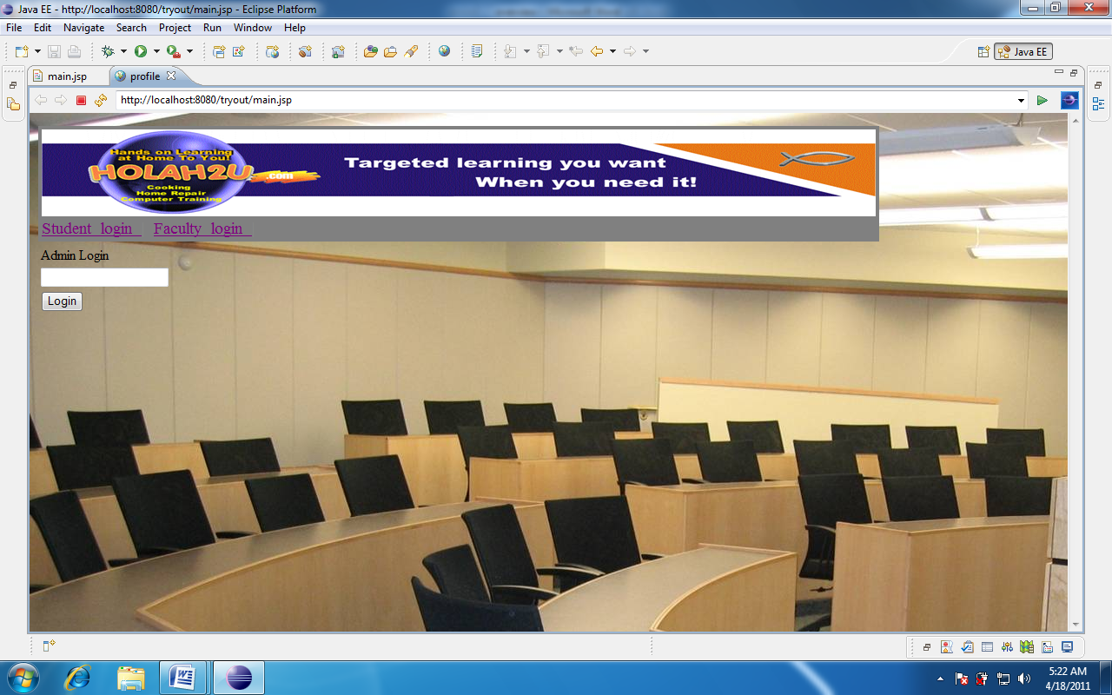
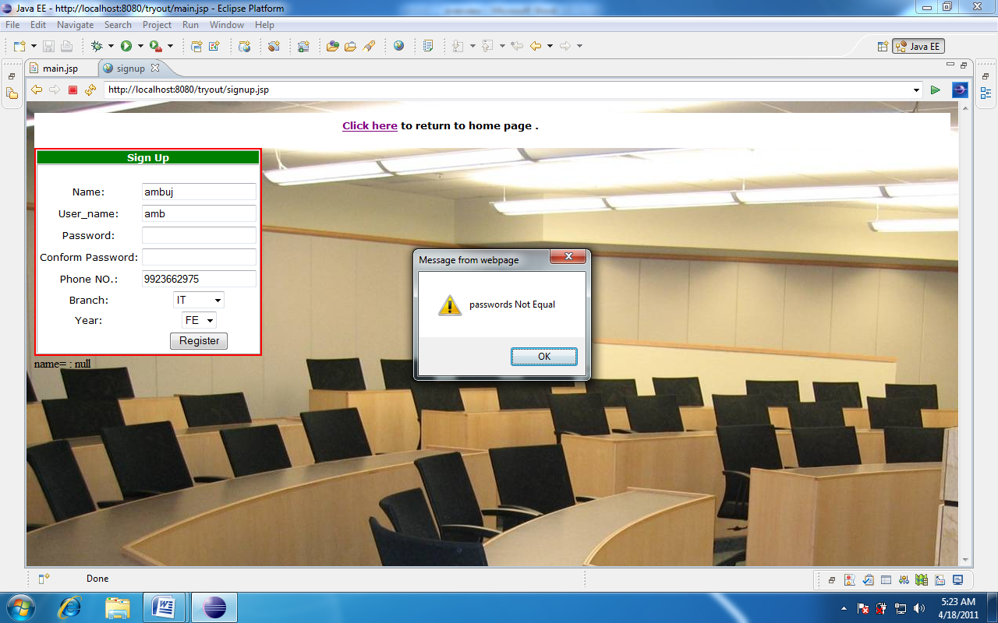

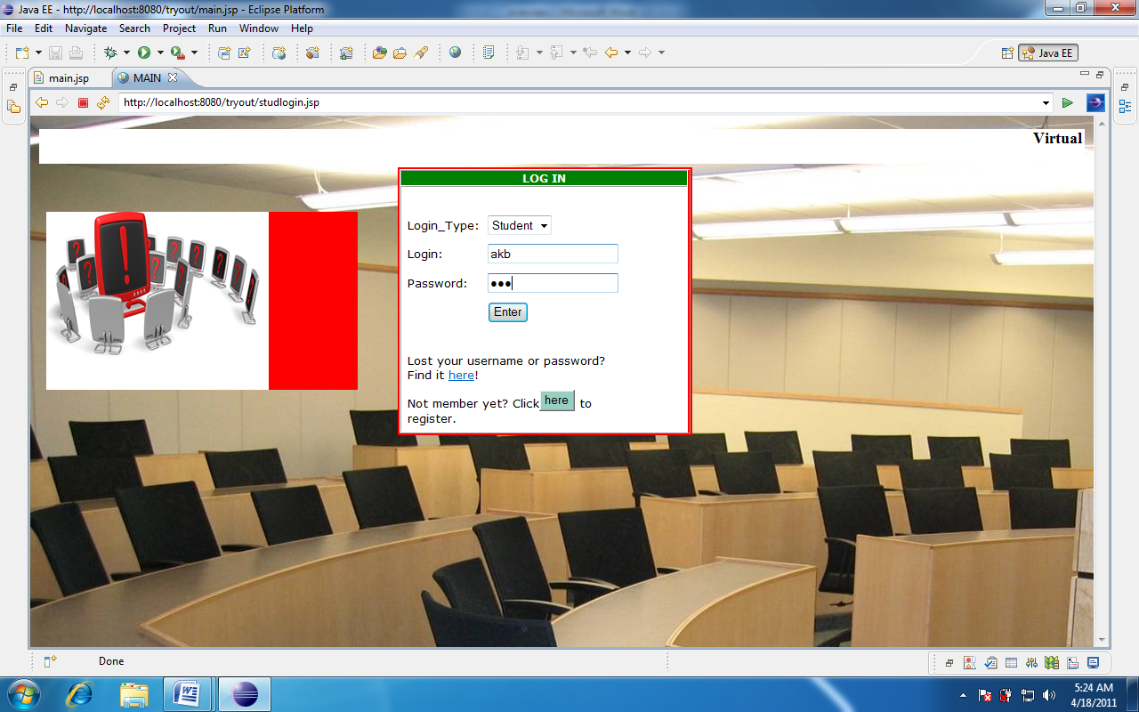
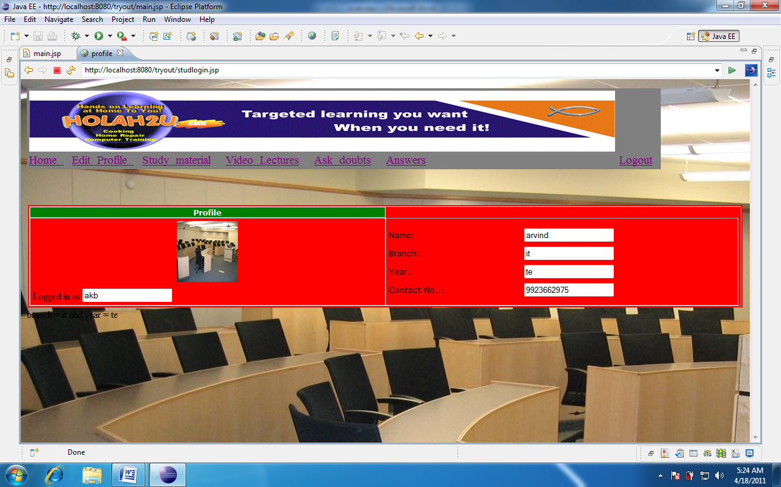

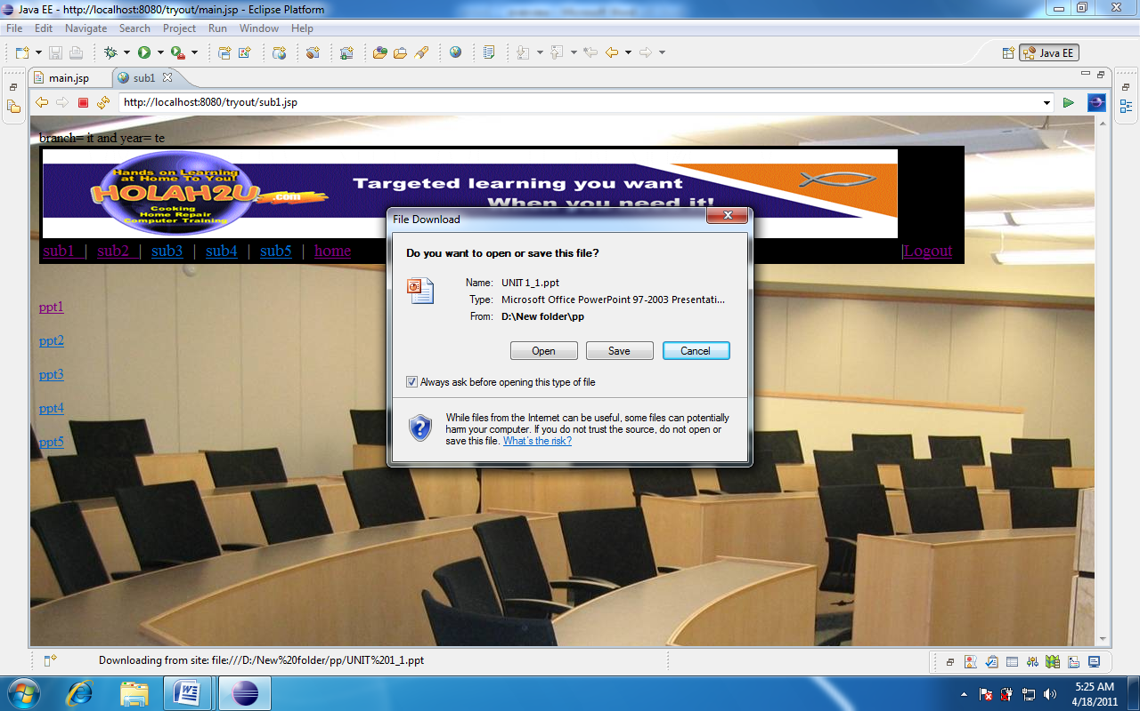

CONCLUSION
A computerized alumni management system has been developed and the system was tested with sample data.
The system results in regular timely preparations of required outputs. In comparison with manual system the benefits under a computer system are considerable in the saving of man power working hours .It also increases the feasability
Provision for addition and deletion of student /faculty is there in the system.It is possible to view information of other student/faculty after successfully logging in. The entire project runs on windows environments.
The system can be used to increase student faculty interaction and also increase their involvement with the college.

SCOPE OF ENHANCEMENT

The system may be further updated or modified at will owing to its simple structure. Facillities such as chat could also be provided.

